AWS Project – 001

VPC Architecture with Public and Private Subnets for Production

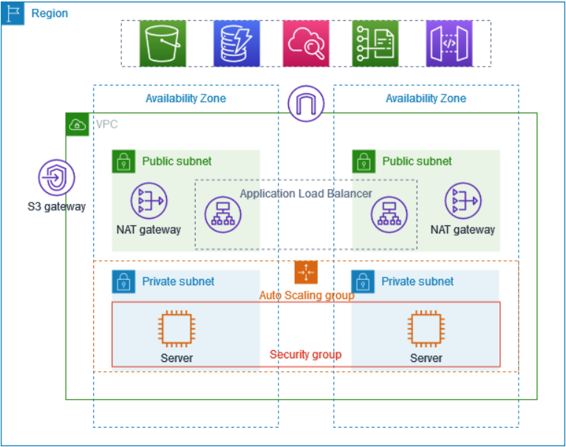
VPC Public-Private Architecture

• Internet Gateway → for public internet access
• NAT Gateway → outbound internet access for private subnets not inbound instance access from internet.
• S3 VPC Endpoint (Gateway) → private, secure access to S3 (Simple Storage Service)

About the Project

This Project demonstrates how to create a VPC that we can use for servers in a production environment.
To improve resiliency (flexibility), we deploy the servers in two Availability Zones, by using an Auto Scaling group and an Application Load Balancer. For additional security, you deploy the servers in private subnets. The servers receive requests through the load balancer. The servers can connect to the internet by using a NAT gateway. To improve resiliency, you deploy the NAT gateway in both Availability Zones.

Key Concepts
- Auto Scaling Group: automatically adds, removes, and replaces servers.
- Application Load Balancer: intelligently distributes user requests across those servers.
- Bastion Host: A Bastion Host (also called a Jump Server) is a secure administrative server (Special EC2 Instance) Present in Public subnet used to access instances located in private subnets (Inbound Instance Access e.g. SSH).
- Target Group: An AWS resource that defines and monitors the backend targets (such as EC2 instances) to which a load balancer forwards traffic.

Overview

The VPC has public subnets and private subnets in two Availability Zones.
Each public subnet contains a NAT gateway and a load balancer node.
The servers run in the private subnets, are launched and terminated by using an Auto Scaling Group (ASG), and receive traffic from the load balancer.
The servers can connect to the internet by using the NAT gateway.

Inbound vs Outbound Traffic
- Outbound traffic:
When the EC2 instance itself goes out to the internet to get something.
Example: EC2 downloading updates, software, or calling an external API.
- Inbound traffic:
When someone on the internet tries to come into the EC2 instance without the EC2 asking first.
Example: Trying to SSH or access a private EC2 directly from the internet.

Key clarification
- Private subnet:
  - EC2 can go to the internet (outbound traffic allowed)
  - Internet cannot come to the EC2 by itself (inbound traffic restricted)

Solution Overview

This solution is designed to support a production-grade application deployment aligned with AWS best practices within an AWS Virtual Private Cloud (VPC) by combining scalability, high availability, and security. The infrastructure is distributed across two Availability Zones to reduce the impact of failures and ensure continuous service availability.
User traffic is handled exclusively through an Application Load Balancer (ALB), which acts as the public entry point to the environment and forwards requests to backend servers running in private subnets. These servers are managed by an Auto Scaling Group (ASG), allowing the environment to automatically scale capacity and replace unhealthy EC2 instances without manual intervention.
To maintain network security, private instances do not have direct internet access. Outbound connectivity required for operating system updates and external service communication is provided using NAT Gateways, deployed independently in each Availability Zone to improve fault tolerance and avoid cross-zone dependency.
Administrative access to private instances is restricted and performed through a Bastion Host (Jump Server) located in a public subnet, ensuring controlled and secure inbound access. This design follows AWS production best practices and provides a smooth transition into the detailed Architecture Design section that follows.
Architecture Design

High-Level Architecture Description
This project follows a highly available, secure, and scalable VPC architecture suitable for production workloads. The design uses multiple Availability Zones (AZs) to eliminate single points of failure and ensure service continuity.
The architecture separates public-facing components and private application components using subnet isolation.
Architecture Components and Flow
1. Virtual Private Cloud (VPC)
- A dedicated Virtual Private Cloud (VPC) is created to logically isolate network resources.
- The VPC spans two Availability Zones within the same AWS Region to ensure high availability.
2. Subnet Design
Each Availability Zone contains:
- One Public Subnet
- One Private Subnet
Public Subnets
- Host the following resources:
  - Application Load Balancer (ALB)
  - NAT Gateway
  - Bastion Host
- Have direct internet access through an Internet Gateway (IGW).
Private Subnets
- Host application servers (EC2 instances).
- Do not allow direct inbound access from the internet.
- Outbound internet access is provided via NAT Gateways.
3. Internet Gateway (IGW)
- Attached to the VPC.
- Enables inbound and outbound internet connectivity for public subnets.
- Required for the Application Load Balancer and Bastion Host.
4. Application Load Balancer (ALB)
- Deployed across both public subnets.
- Listens for incoming HTTP/HTTPS requests.
- Distributes traffic across EC2 instances running in private subnets.
- Performs health checks to route traffic only to healthy instances.
5. Target Group
- Associated with the Application Load Balancer.
- Contains EC2 instances launched by the Auto Scaling Group.
- Continuously monitors instance health.
- Automatically removes unhealthy instances from traffic routing.
6. Auto Scaling Group (ASG)
- Launches EC2 instances in private subnets across both Availability Zones.
- Automatically:
  - Scales out during high load.
  - Scales in during low load.
  - Replaces unhealthy instances.
- Ensures consistent application availability.

7. NAT Gateway (Highly Available Setup)
- One NAT Gateway is deployed in each public subnet.
- Private subnet route tables are configured to use the AZ-local NAT Gateway.
- Enables outbound internet access for:
  - Software updates
  - Package installations
  - External API calls
- Prevents inbound internet access to private instances.
8. Bastion Host (Jump Server)
- Deployed in a public subnet.
- Used for secure administrative access (SSH) to private EC2 instances.
- Reduces attack surface by avoiding direct access to private servers.
- Access restricted using Security Groups and trusted IP addresses.
Request Flow (End-to-End)
- User sends a request from the internet.
- Request reaches the Application Load Balancer via the Internet Gateway.
- ALB forwards traffic to the Target Group.
- Target Group routes the request to a healthy EC2 instance in a private subnet.
- EC2 instance processes the request and sends the response back through the ALB.
- For outbound internet access, EC2 instances route traffic through the NAT Gateway.
Architecture Benefits
- High Availability: Multi-AZ deployment for all critical components.
- Scalability: Auto Scaling Group adjusts capacity automatically.
- Security: Private subnets, NAT Gateways, and Bastion Host.
- Fault Tolerance: Health checks and automatic instance replacement via ALB.
- Production-Ready Design: Aligns with AWS Well-Architected Framework.
Architecture Visual Evidence

- Region
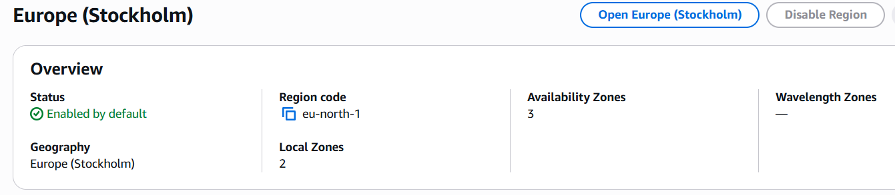

- VPC (Vistual Private Cloud)
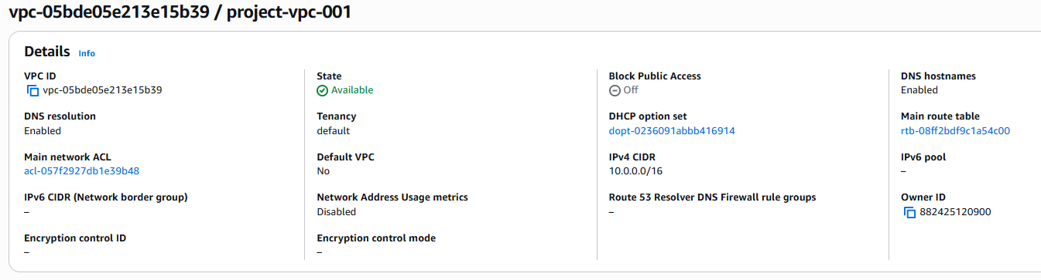
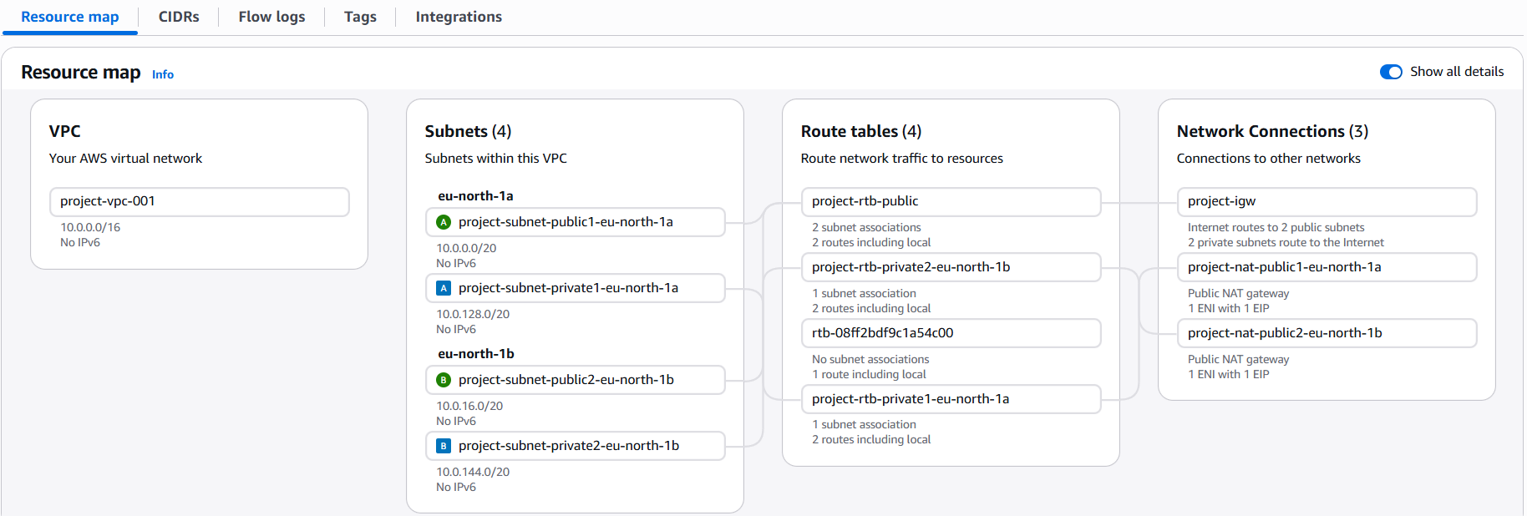

- AZ (Availability Zones)
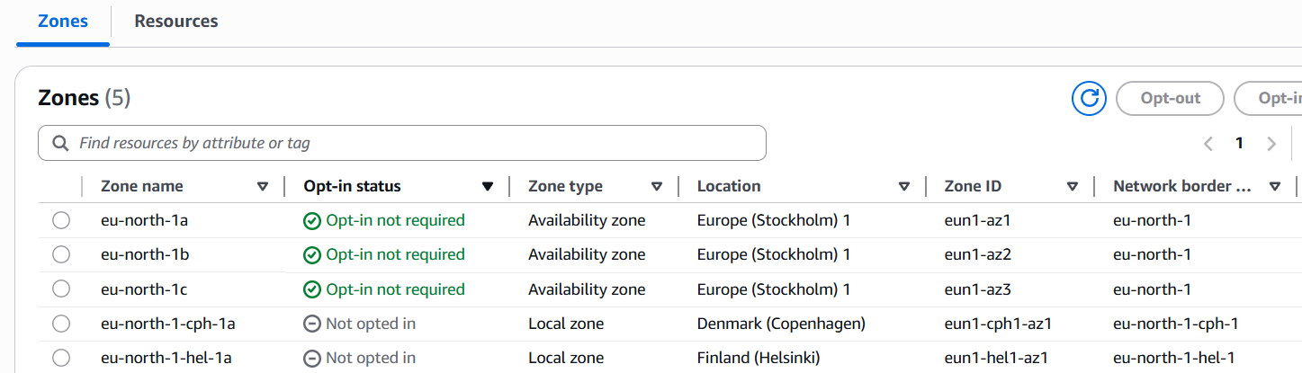

- Subnets

AZ-1 Public-Private Subnets
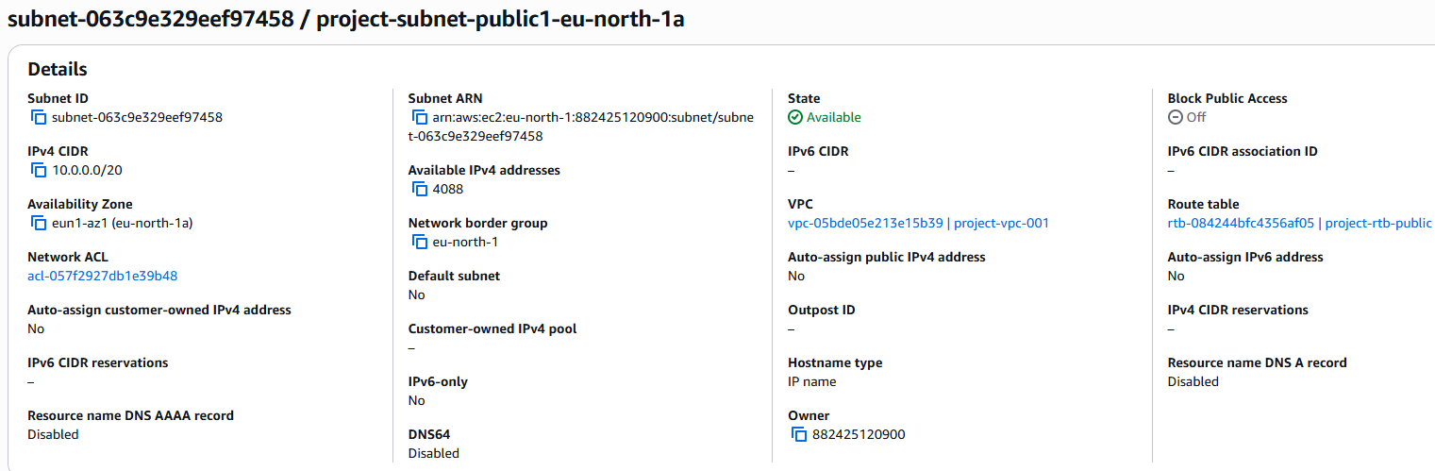
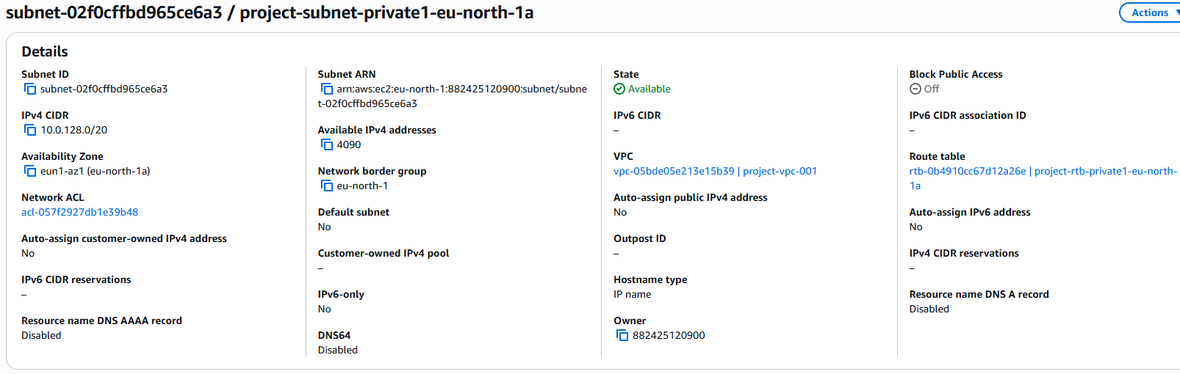

AZ-2 Public-Private Subnets
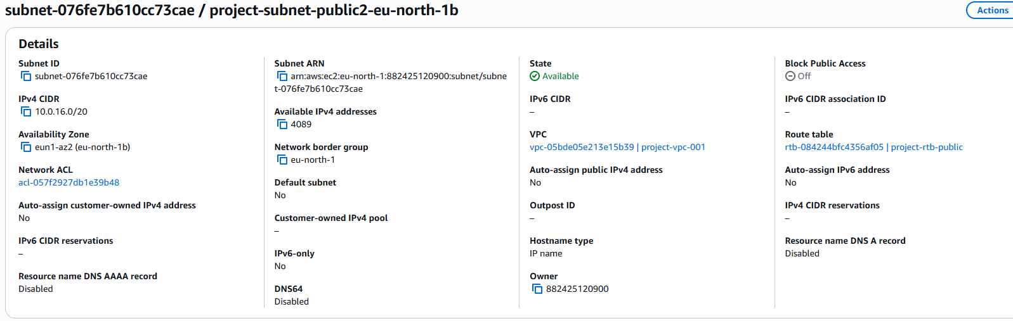
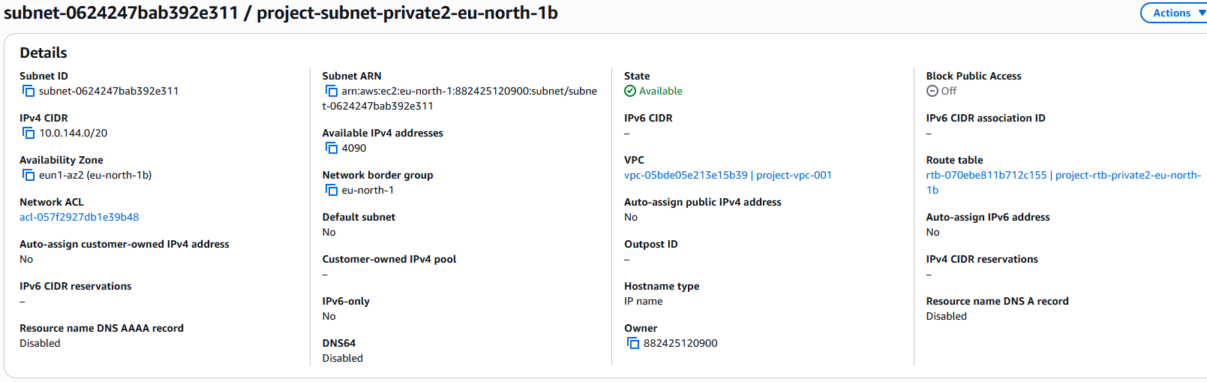

- Route-Table :

- ASG (Auto-Scaling Group)

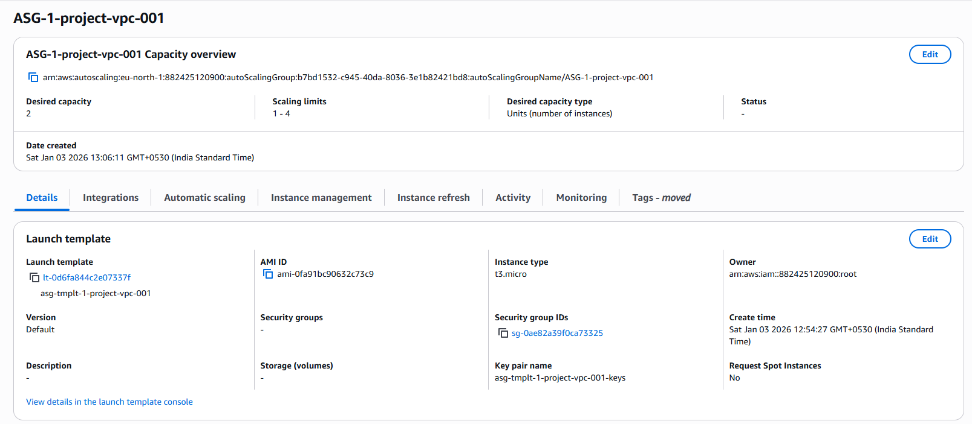

- EC2 Instances :
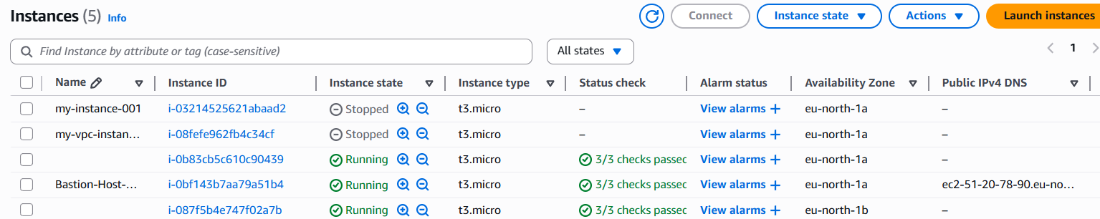

- Private EC2 Instances from each Availability zones

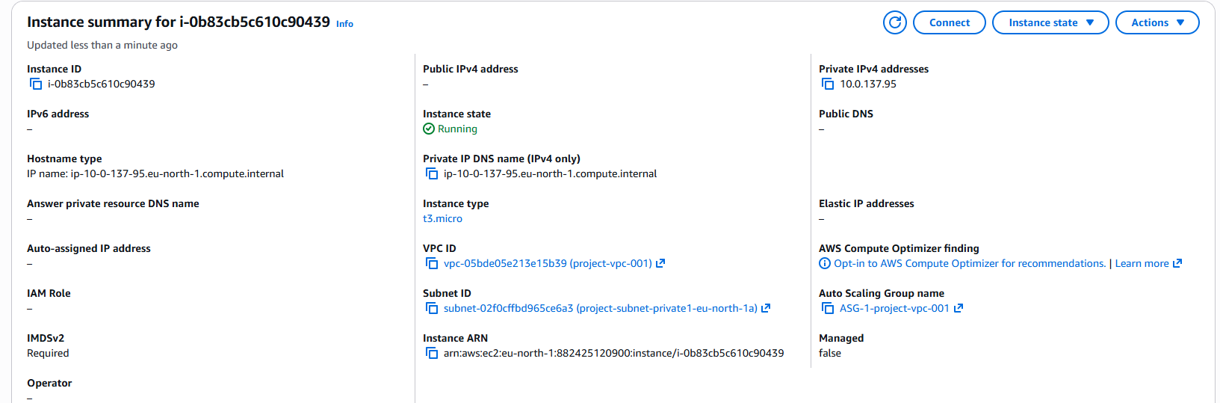
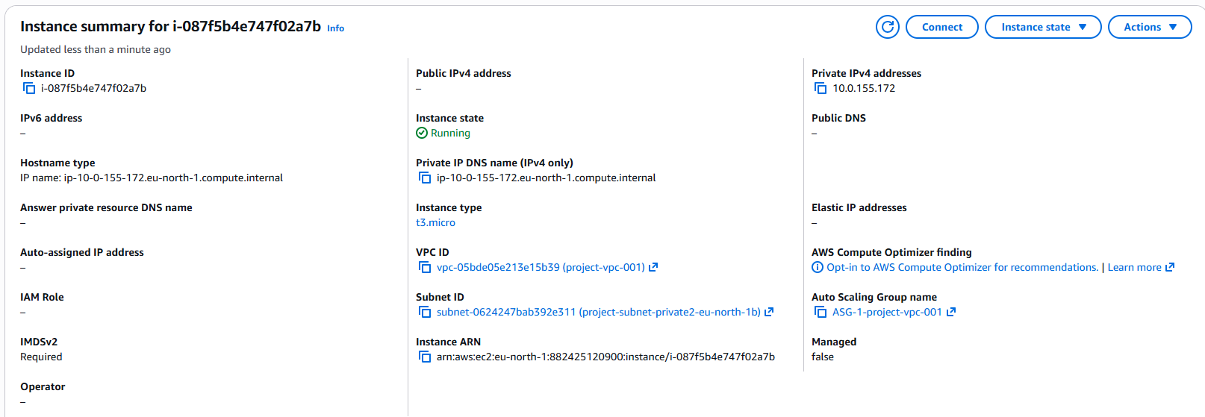

- Target Group
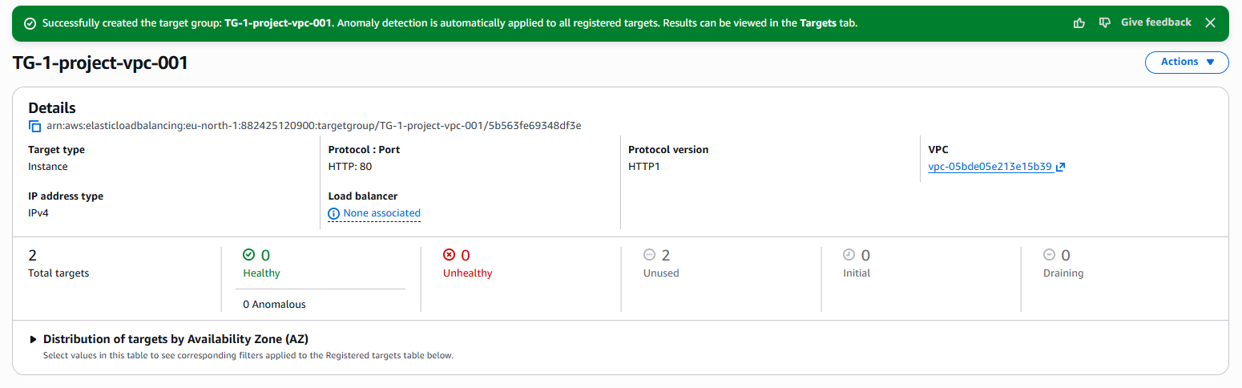

- Bastion Host/ Jump Server
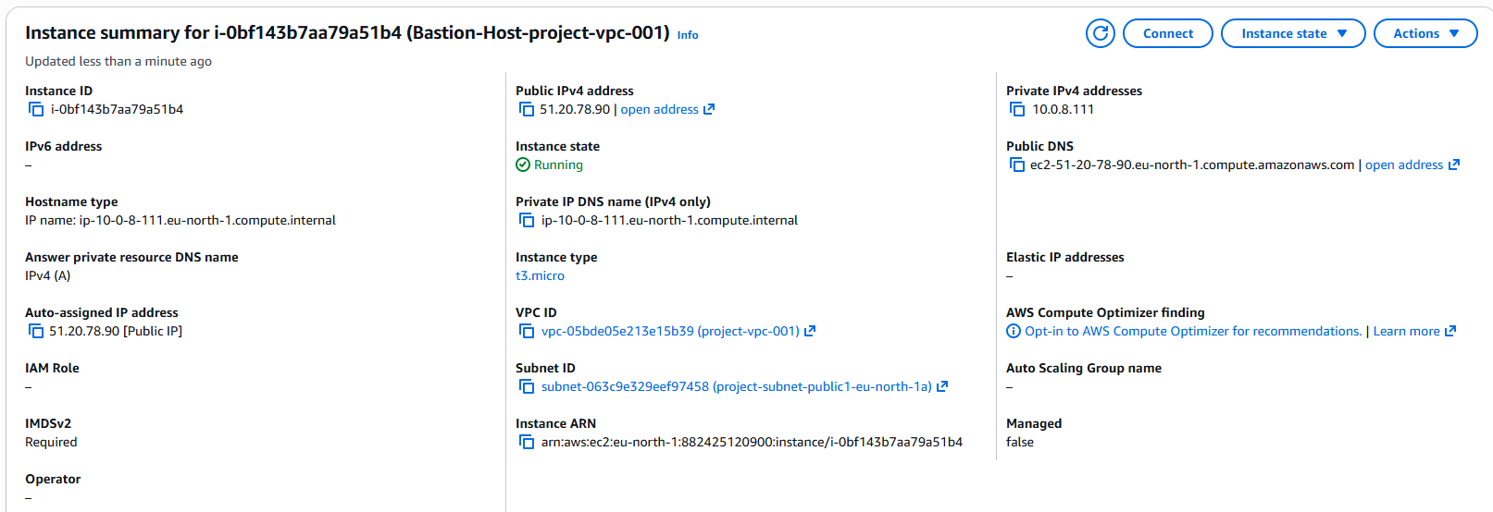

- ALB (Application Load Balancer)
